Demodulating a Real-World Lora Packet

In this project, you are asked to process the signal trace shared with me by the authors of the Sigcomm 2021 paper “Concurrent interference cancellation: decoding multi-packet collisions in LoRa,” where the signal was transmitted by real-world LoRa devices.

There is one packet in the trace you are asked to process, “LoRa_trace_1” in “Files”:

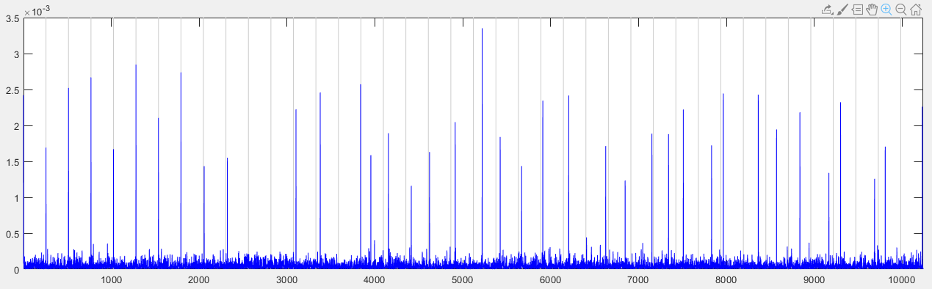

You are given the following information about the packet:

* SF: 8
* Oversampling Factor: 8
  + Means that between for each transmitted sample, the receiver takes 8 samples. The bandwidth in the experiment was 250 kHz. The receiver takes samples at 2 MHz.
* Packet starting location in the trace: 217626
* CFO: -1.57
  + This is the number of cycles of the CFO sinewave within a symbol time. To cancel the CFO, you would just need to multiply the trace with a sinewave at this frequency (-1.57).

In this project, you are asked to find the peak locations of the data symbols (first location is 0, last is 255):

29 49 253 113 57 61 13 49 100 49 37 22 61 226 191 240

173 85 151 28 170 122 132 206 83 214 79 245

The peak locations can be fed to a LoRa packet decoding program. Here is the content of the packet for your information:

12 48 160

255 255 0 0 76 111 82 97 80 107 116 0 41 23 156 4 1

You would need to follow the following procedure for the demodulation of the packet:

1. Extract the samples from the packet starting location, referred to as S, to S+(12.25+28)*256*8-1. This segment contains the entire packet.
2. Correct the CFO by multiplying the segment with a sinewave with frequency CFO.
3. Skip the first 12.25 symbols, which is the preamble.
4. For each data symbol,
   1. Read one sample every 8 samples, which should give you 256 samples, call it vector Y.
   2. Elementwise-multiply Y with the conjugate of the base chirp, to get a vector called Z.
   3. Calculate the FFT of Z.
   4. Output the highest location of abs(fft(Z)).